Excerpts from LM35 datasheet:
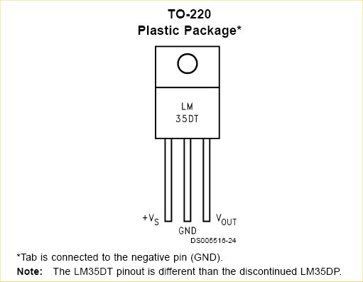

Rob
+Vs = red
Gnd = black
Vout = yellow

Max. soldering time 10sec.

← Jeff !
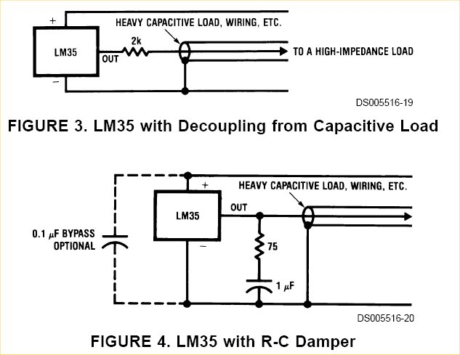
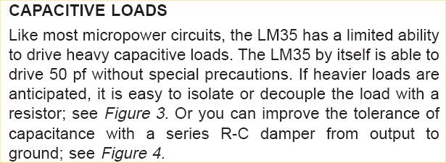

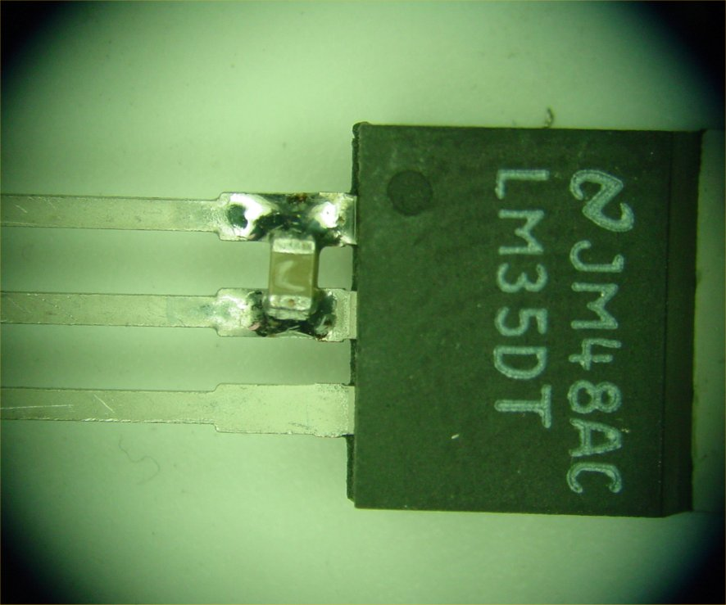
0.1μF

